*Unearthing the Environmental Impact of Human Activity: A Global CO2 Emission Analysis*

*GANESAR COLLEGE OF ARTS AND SCIENCE*

*Melaisivapuri, Pudukkottai*

*Faculty Mentor: A. Vadivelmurugan, Assistant Professor*

*Project Done By*

*KEERTHIKA.V – Team Leader*

*MEENAKSHI.G - Team Member*

*MOHAMED ANVAR.S - Team Member*

*NANDHINI.N - Team Member*

*PAVITHRA.PL - Team Member*

*INTRODUCTION*

*Global warming is one of the biggest challenges currently being faced by the human race, although correlation is not causation, a likely cause of global warming is due to increased atmospheric carbon dioxide from human activity. CO2 Emission refers to the Carbon Dioxide emitted throughout the world.*

*Analysis Global Co2 Emission across countries from 1975 to 2020. This dataset contains a record of Co2 Emission by each Country and Region of Earth, here we are going to analyses and visualize Country wise, Region wise and Overall Co2 Emission on Earth*

|  |  |  |  |  |  |  |
| --- | --- | --- | --- | --- | --- | --- |
|  |  |  | gas co2 in global |  |  |  |

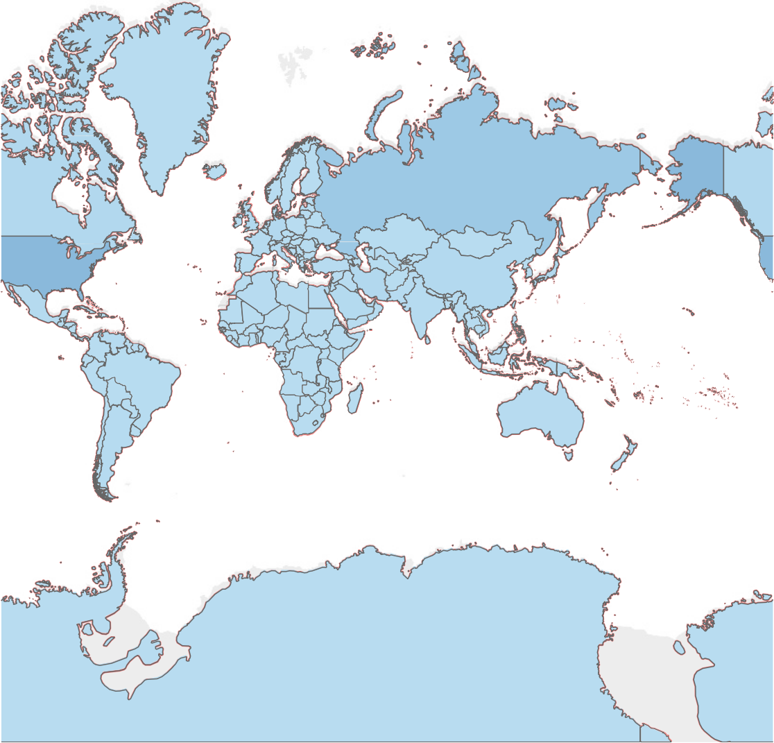Gas Co2

0 213,047

|  |  |
| --- | --- |
| on  .. | co2 emission per capita |

Co2 Growth Prct

Measure Names

20

19.073

21.368 22.178

21.850

21.329

20.814

22.088

26.212

21.229 21.295 22.136 23.627

26.44124.455

26.105

26.647

20.823

21.628

19.706

21.059 21.237

21.985 22.622

23.421

10

0

230.89

239.91

225.57

238.56

270.37 274.22

253.04 262.38

228.43

221.37

200

227.51

218.21

210.40

198.24

190.01

214.86

204.47

219.25 211.72

218.36 213.22 218.80

223.38

208.93 204.81

100

0

4K

4,206

2,324

2K

1,701

1,536 1,590

1,255

1,375

1,111

1,218

1,194

1,068

1,172

1,208

533

1,457

1,178

862

903 849

953

0K

101

248

4

622

224 291

1,099 842

1,284

593

640 441 505

794

341

590

544 378 517 544

-1,638

300

287.8 300.7

265.4

246.4

260.4

252.0

307.5 297.1

296.7 295.5

303.0

223.2

274.1

282.0

291.1

195.9

246.9

251.1 260.0

200

179.2

164.9

220.6

130.1

190.2

129.7

162.9

144.5

100

122.6

0

Cement Co2 Per Capita

1975 1980 1985 1990 1995 2000 2005 2010 2015 2020

Gas Co2 Per Capita

Year

|  |  |
| --- | --- |
|  | trade co2 share of countries |

0

-644

0

50

0

0 0

167

522

122

0

165

0

0

0 0

0

0

0

0

0

00

538

-281

0

0 0 00 0 0

1,5

1,478

-869

207

0

0

© 2023 Mapbox © OpenStreetMap

Trade Co2 Share

-1,135

0

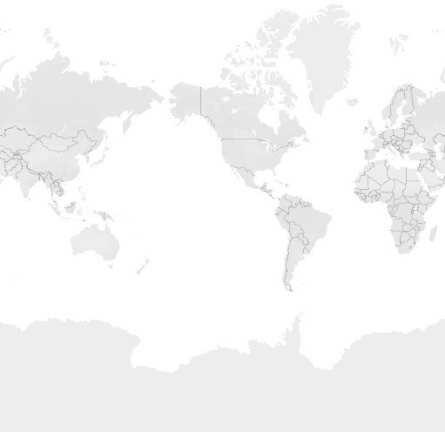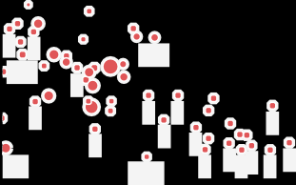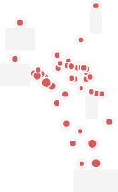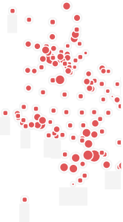

 2,000

 4,000

 5,682

|  |  |  |  |  |  |  |  |
| --- | --- | --- | --- | --- | --- | --- | --- |
|  |  | cumulative co2 emission of diﬀerent .. |  |  |  |  | |
|  | | | | | | |  |

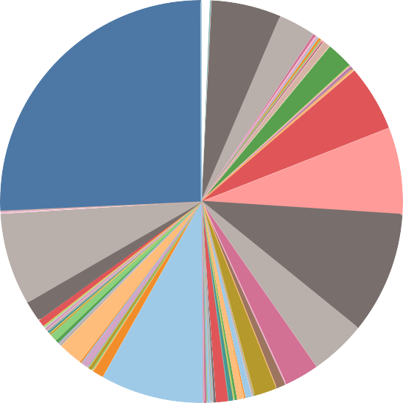

23,960

602

Country

Afghanistan Africa Albania Algeria Andorra Angola Anguilla Antarctica

Zimbabwe Antigua and Barbuda

1,106

Antigua and Barbuda Argentina

47,154,137

World

5

Bonaire Sint Eustatius and Saba

9,795,177

EU-27

12,868,790

EU-28

Armenia Aruba Asia

Asia (excl. China & Ind.. Australia

Austria Azerbaijan Bahamas Bahrain Bangladesh

Wallis and Futuna

13,499,862

United States

127

Saint Vincent and the Grenadines

15,158,487

52,709

17,983,758

Europe

8,222,242

Europe (excl. EU-27) 0

French Equatorial Africa

Barbados Belarus Belgium Belize Benin Bermuda Bhutan Bolivia

Bonaire Sint Eustatiu..

Bosnia and Herzegovi..

North America

New Zealand

Botswana Brazil

British Virgin Islands Brunei

Bulgaria Burkina Faso

Cumulative Co2

183,549,727

|  |  |
| --- | --- |
|  | CO2 emission from diﬀerent sources |

Gas Co2

Flaring Co2

Coal Co2

1975 1980 1985 1990 1995 2000 2005 2010 2015 2020

40K

20K

0K

1500

1000

500

0

30K

20K

10K

0K

40K

30K

20K

10K

0K

Oil Co2

Year

|  |  |  |
| --- | --- | --- |
|  |  | DASHBOARD |

# co2 emission in global

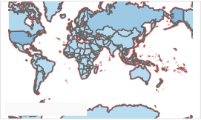

© Mapbox © OSM

country vs co2 trade emission



© Mapbox © OSM

# year vs co2

115,021

country vs co2

1,106

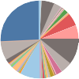Bonaire Sint Eustatius and Saba

127

Saint Vincent and the Grenadines

# co2 per capita

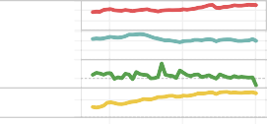

0

0

5K

200

Ga..Co..Co..Ce..

1980 2000 2020

Year

# year vs co2 emission in types

1980 1990 2000 2010 2020

Oil Co2

Gas Co2

Flaring Co2 Coal Co2

Year

Country

Afghanistan Africa Albania Algeria Andorra Angola Anguilla Antarctica



c

yearly wise

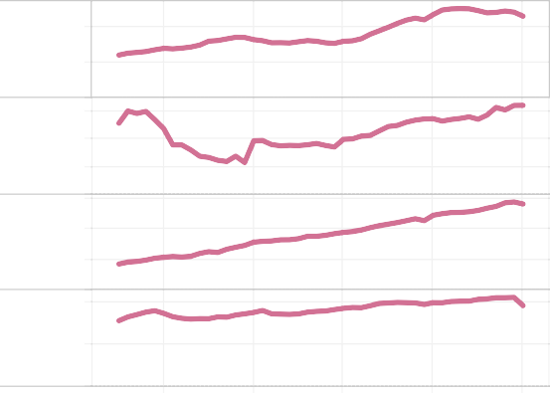

40K

20K

1500

1000

500

20K

10K

40K

20K

0K

Antigua and Barbuda Argentina

Armenia Aruba Asia

Asia (excl. China & Ind.. Australia

Austria Azerbaijan Bahamas Bahrain Bangladesh

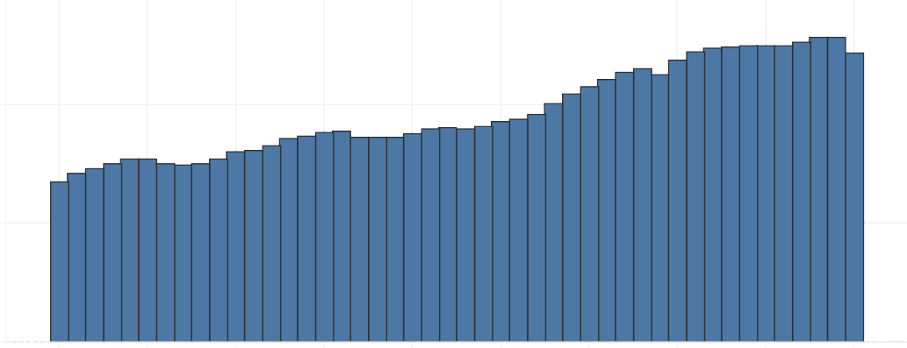Cumulative Co2

183,549,727

88,759

89,954

100K

Gas Co2

 0 213,047

74,498

50K

Co2

77,269

Measure Names

Cement Co2 Per Capita Co2 Growth Prct

86,353

Coal Co2 Per Capita Gas Co2 Per Capita

0K

1975

1980

1985

1990

1995

Year

2000

2005

2010

2015

2020

Trade Co2 Share

-1,135

0

 2,000

 4,000

 5,682

*CONCULYUTION*

*We have extracted the Insights from the data and put the data in the form of visualizations, Story and Dashboards. We concluded from that visualization China, is a country, have large assets in the banking industries.*